Originator:
Name | Job Title | Signature | Date
Andrew Mason | Chief Technology Officer
Approvals:
Name | Job Title | Signature | Date
Nancy Rizzo | Founder and CEO
Scott Pletzer | Director of Quality & Program Management

- Purpose
The purpose of this document is to describe the specifications developed for the patient demographics functions. The specifications include not only the data collection of patient medical history, but also the ability to search and find patient medical history information. The patient demographics will be used to track and store ClearView image and analysis data.

- General Requirements

Where appropriate, logic should be contained in try/catch blocks and any exceptions should be logged using the standard logging mechanisms.

- Definitions

Try/catch blocks | A flow control handling mechanism that allows the capture of exceptions that occur during the execution of a block of code.
EPIC Central | A SaaS based application that will be used amongst other things to archive data collected by the ClearView systems.

- Specifications

Requirement #4.1: Users must be able to search for a patient in the system. All new patient entry must begin with the search screen. This is to ensure that the specific patient being entered does not already exist.

Specification: The Manage Patient button is the only method to access the Patient Demographics. The first action is to open a Search Patient dialog box in order to determine if the patient already exists in the database.

Requirement #4.2: To search a patient, the user is prompted to enter at a minimum the patient’s first or last name. Additionally, search can be conducted by the patient’s birth date and gender in order to narrow the search results.

Specification: The Search Patient dialog allows the user to enter at least a portion of the first name, last name, birth date, and/or gender of the patient.

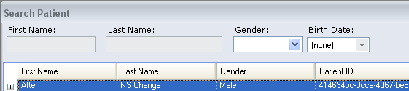

Requirement #4.3: The system displays zero or more results for the search criteria entered.

Specification: After clicking the Find button, the database returns all results that meet the search specifications. If no results are found, the search display grid will remain blank.

Requirement #4.4: If the appropriate patient is not found, then the user is presented with the ability to create a new patient profile.

Specification: Once the search results are returned, the Add Patient button is available in the Search Patient dialog box. The Add Patient button opens the Demographic window for data entry of patient information.

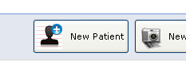

Requirement #4.5: If the patient is found, then the user is able to view the patient demographics information, capture a new scan for the patient selected, or enter a new patient profile.

Specification: Once the search results are returned with patients that meet the search criteria, users may select a specific patient listed and have the options to view the Patient Demographics information, Capture a new scan for the patient selected.

Requirement #4.6: All fields should be audited. An audit trail should be kept for each data point, consisting of the following tracking points:

    - ID of the user that performed the change.
    - Date and time of the change down to the minute.
    - The before and after values.
    - The name of the data point.

Specification: When a patient record is either created or edited the information is captured and audited in the persistence layer. This prevents people from changing the data before it is saved to the system.

The audited data is captured and placed into a database table called ‘AuditInfo’. The table consists of the following structure:

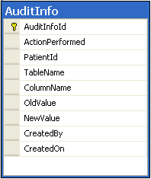

An example of the captured data is below; no data can be added or changed on the patient record without an audit trail being created.

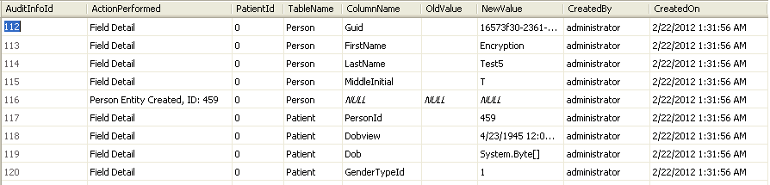

Requirement #4.7: After a search, if the patient is found, then the user is able to view the patient demographics information, capture a new scan for the patient selected, or enter a new patient profile.

Specification: By selecting a user that was retuned in the results set and pressing the View Patient button, the demographic information can be viewed and edited.

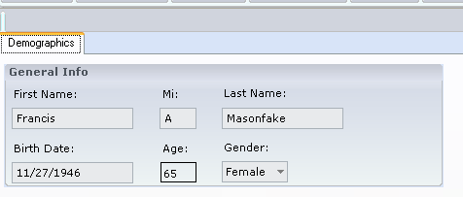
Any changes made to the patient record are audited.

Requirement #4.8: The demographics collected will consist of the following points, the table below represents the name of the data, a validation if any and the requirement of the field to complete data entry:

Field Name | Validation | Required
First Name | None | Yes
Last Name | None | Yes
Middle Initial | None | No
Birthdate | Valid date in format mm/dd/yyyy | Yes
Gender | Either Male or Female | Yes

Specification: The patient data is stored in two tables, Person and Patient. A number of the fields used are either encrypted or hashed for security purposes.

The validations specified in the requirement have been implemented; the form cannot be saved until the validations are all satisfied.

The patients’ is calculated for display.

Requirement #4.9: The user can either cancel out of the process (Cancel) or they can save the information (Save).

Specification: When creating or editing a patient, the user can either click the save icon at the top of the application to save the changes, or they can click the X in the upper right corner of the window. If the user attempts to close the window before saving (and data has been changed) they will be prompted with a warning.

Requirement #4.10: All data will be saved on the local system located at the client location. This includes all information contained on the patient intake form and the unique identifier generated based upon the patients name, date of birth and gender.

Specification: All data for the application is stored in a local Microsoft SQL Server 2005 (or later) database.

Requirement #4.11: A user can add to or update any of the existing patient’s information in requirement 4.8.

Specification: All displayed fields (with the exception of the calculated age value) can be edited by the user. All edits are subject to the validations that have been configured for the field.

Requirement #4.12: The ClearView system must upload any new patients that are added to the system.

Specification: The ClearView system will make a call to the Snychronization service to add a patient on EPIC Central when the patient is added to the local ClearView system. The synchronizer process guarantees that the data will make it to EPIC Central.

Requirement #4.13: The user should be able to go directly to the scanning functionality once a new patient has been saved.

Specification: A new button was added to the Add Patent process that will allow the operator to go directly to the scan process from the add patient process.

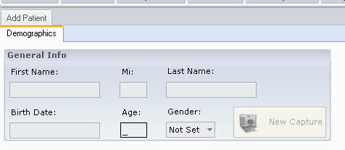
The button will remain inactive until the new patient is successfully saved to the database. The button will be enabled when an existing patient is loaded.

Document Revision History
Version Number: | Description of Change: | Date: | Updated by:
000 | Introduction | 5/24/11 | A. Mason
001 | Added audit trail requirement.  Removed outdated demographic requirements | 3/5/12 | A. Mason
002 | Added the specifications for the ability to upload patient demographic information to EPIC Central. Added the specification for allowing the user to go directly from the Add Patient screen to the scanning process. | 7/18/12 | A. Mason

